EAPA Meeting, Tuesday, March 4th – Thursday, March 7th

General information
Address:
- Q Point, Rennweg 46 – 50, Top 29, 1030 Vienna
- Entrance: Kleistgasse (Stage 4, 5th floor)
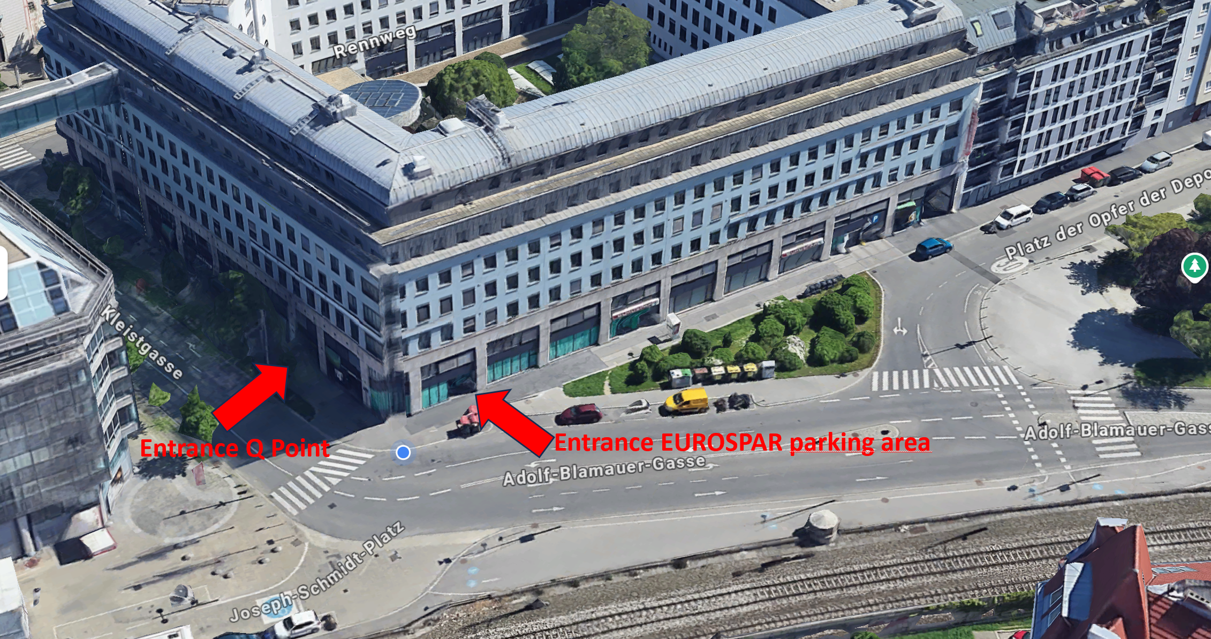
- You can use the parking area (see entrance EUROSPA) if you arrive with car. We will provide a ticket to exit.
Hotels close to the venue:
- Imperial Riding School Renaissance Vienna Hotel
- Austria Trend Hotel Savoyen Vienna
- Lindner Hotel Vienna Am Belvedere
Public transport from the airport
- Take a train (not the City Airport Train (CAT) from Vienna Airport to „Rennweg“. This station is close to the hotels and tot he office.

Technology in the meeting room
- Wifi connection
- Large screens to connect the video call
- Video / Microphone: we will check our equipment, maybe I will come back to you
Program
Tuesday, March, 4th: Health & Safety Committee
- Lunch: in the office
- 16:00: Departure to visit „Pittel & Brausewetter“ (https://www.pittel.at/en/home/) asphalt plant (by private bus)
- 16:30 – 17:30: Visiting of the asphalt plant
  - Challenges of an asphalt plant located in the city of Vienna
- 17:30 – 17:45: Walk to the restaurant
- Dinner in „Gasthaus Koci – Biergarten“ (https://www.koci.wien)
- 21:00: Transport back to the hotels

Wednesday, March, 5th: Technical Committee
- Lunch: in the office
- 16:00: Departure to city center of Vienna (by public transport)
- 16:30 – 17:15: Guided tour through one oft he most beautiful buildings in Vienna
  - State hall of the Austrian National Library (13 EUR / person)
- 17:15 – 18:30: „Non guided“ tour through the city center of Vienna
- 18:30 – 21:00: Dinner in „Zwölf Apostelkeller“, Sonnenfelsgasse 3, 1010 Vienna (https://www.zwoelf-apostelkeller.at) one of the oldest restaurants in Vienna
- Walking back to the hotel or visiting Sky Bar (https://skybox.at/en/)
Thursday, March 6th: Asphalt 4.0 Committee & Communication Committee
- Lunch: in the office

